Welcome to your

Wentworth Community Gym

If you do not already make your health and fitness a priority then take the first step to a healthier and stronger body...Wentworth’s community gym is there to support you to improve your self-image, overall health, and quality of life.

A regular fitness routine has been shown to deliver a host of benefits including increased muscle tone, decreased body fat, improved energy levels, a reduction in stress, and improved cardiovascular fitness.

Are you lacking motivation? Has it been a while since you participated in fitness activities or perhaps you lack confidence in the use of the equipment, or unsure where/how where to start? We can help you to find your way back into the gym, and to start living your healthy lifestyle.

“The hardest part is starting. Get that out of the way, and you’ll find the journey is much easier."

Equipment: Inspire Functional Trainer – capable of a total body workout with wall charts to guide you in planning and executing your daily routine.

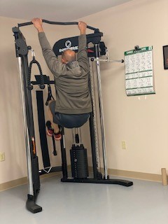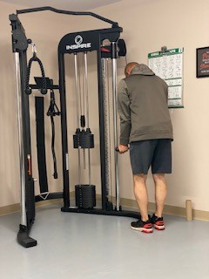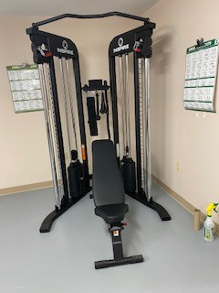

Barbell standard bench adjustable – give your bench press a go! Also recently added to toss around when doing weighted squats or overhead press is an Olympic weight set.

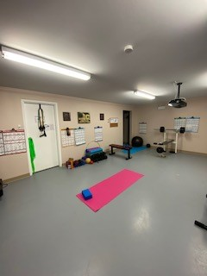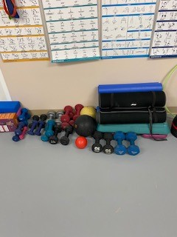

Other weightlifting and resistance equipment includes dumbbells, medicine balls, adjustable weight kettlebells and a variety of resistance bands with wall charts to guide you in your form and routine.

Cardio equipment – variety of ellipticals, bikes and tread mills.
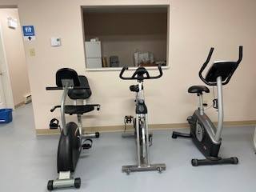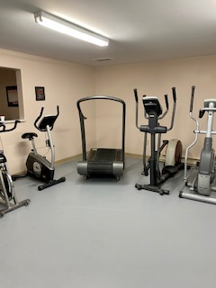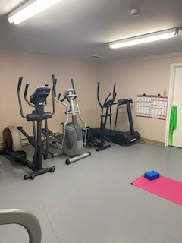

LOCATION -On the lower level of the Rec Centre, it is accessible from the front lobby entrance near the Post Office.

Access:
Available timings are:
Front entrance access:
Monday to Friday daytime 9 - 430
Side entrance access:
Sunday/Tuesday 6-8 pm
Thursday 6-9 pm
Saturday 10am -12 pm
(timing may change based on regular scheduled activities changing)
Gym membership cost: (available at the Post Office)
Adult: $10/month
Student: $5/month
Adult: $100/year
Student: $50/year
$2/visit (honor system)
Family: $30/month
Family rate: $250/year (family consisting of 2 adults and all children up to 18 years of age residing in the same household and any full-time university students up to 25 years old)
All patrons must sign a waiver, persons under 18 must have a waiver signed by a parent or guardian. Persons under 16 years must be accompanied by an adult. All patrons must sign in and out. (Log and waivers located on the counter in the gym)
Assistance available:
If you are interested in improving your fitness, however unfamiliar with equipment usage, require assistance in how to perform exercises our volunteers are available to assist you. They can also help you develop your fitness plan. Call/text them to plan to get you started on your fitness regimen.
Call/text:
Kathy: 902-664-8833
Velma: 902-817-1906
Jamie: 902-430-6901
You are also welcome to hire your own Personnel Trainer and have them utilize our facility. Celene Bartlett, a certified Personnel Trainer and Nutrition Coach is available for hire and can be reached at: 902-956-8256.

